Database Design –Assignment 4

Remember: double quotes for all character and date attributes,   
All names should be in mixed case with no spaces

NO COPYING! Help each other but do your own work. Otherwise you will be given an "F" for the class.

You have inherited a small catering company that is losing money. You suspect you are not charging enough for the dinners so you decide to put the components of the dinners in a database so you can use your new SQL skills to analyze your financial status. Fortunatly, each food item is used in only one dinner. (use the data in the table below) The Fish dinner includes Salmon, a house salad, and beans; the chicken dinner includes cordon bleu, corn, a roll and ice cream; the steak dinner includes NY strip steak, a ceasar salad, asparagas, and pie.

| **DinnerEntree** | | | | |
| --- | --- | --- | --- | --- |
| **ItemID** | **ItemName** | **ItemCost** | **ItemPrice** | **ItemDinner** |
| 1000 | Fish Dinner |  | 6.77 |  |
| 1001 | Chicken Dinner |  | 8.05 |  |
| 1002 | Steak Dinner |  | 10.85 |  |
| 100 | Salmon Filets | 3.95 | 4.50 | 1000 |
| 201 | House Salad | 0.75 | .97 | 1000 |
| 301 | String Beans | 1.00 | 1.30 | 1000 |
| 101 | Cordon Bleu | 4.25 | 4.75 | 1001 |
| 303 | Corn | .65 | 0.90 | 1001 |
| 401 | Ice Cream | 1.60 | 2.10 | 1001 |
| 501 | Dinner Rolls | .25 | 0.30 | 1001 |
| 103 | NY Strip | 4.95 | 5.55 | 1002 |
| 202 | Caesar Salad | 1.20 | 1.45 | 1002 |
| 302 | Asparagus | 1.10 | 1.40 | 1002 |
| 402 | Pie | 1.85 | 2.45 | 1002 |

**Copy/paste your ERD and SQL code into this Word document below each numbered requirement.**

1. Use Visio to draw the ERD for this table. See "How to Create a Recursive Relationship in Visio" for help. Paste the ERD here.



Use Create and Insert statements, to create and populate the table. Name it DinnerEntree.   
Set ansi_nulls on

Go

Set quoted_identifier off

Go

Drop Table DinnerEntree

Create Table DinnerEntree (

ItemID int not null,

ItemName varchar(15),

ItemCost money,

ItemPrice money,

ItemDinner int,

Primary Key (ItemID))

Insert Into DinnerEntree

values (1000,"Fish Dinner",NULL,6.77, NULL)

Insert Into DinnerEntree

values (1001,"Chicken Dinner",NULL,8.05, NULL)

Insert Into DinnerEntree

values (1002,"Steak Dinner",NULL,10.85, NULL)

Insert Into DinnerEntree

values (100,"Salmon Filets",3.95,4.50, 1000)

Insert Into DinnerEntree

values (201,"House Salad",0.75,0.97, 1000)

Insert Into DinnerEntree

values (301,"String Beans",1.00,1.30, 1000)

Insert Into DinnerEntree

values (101,"Cordon Bleu",4.25,4.75, 1001)

Insert Into DinnerEntree

values (303,"Corn",0.65,0.90, 1001)

Insert Into DinnerEntree

values (401,"Ice Cream",1.60,2.10, 1001)

Insert Into DinnerEntree

values (501,"Dinner Rolls",0.25,0.30, 1001)

Insert Into DinnerEntree

values (103,"NY Strip",4.95,5.55, 1002)

Insert Into DinnerEntree

values (202,"Caesar Salad",1.20,1.45, 1002)

Insert Into DinnerEntree

values (302,"Asparagus",1.10,1.40, 1002)

Insert Into DinnerEntree

values (402,"Pie",1.85,2.45, 1002)

**Write the SQL queries to answer the following requirements. Remember to sort all lists.**

3. List the names of the three dinners without using the three ItemID in the Where statement.  
Select ItemName

FROM DinnerEntree

WHERE ItemID >= 1000

4. List the names of the dinners and names of the component items of each dinner.  
SELECT din.ItemID AS "Component ID", din.ItemName AS "Component Name", comp.ItemID AS "Dinner ID", comp.ItemName AS "Dinner Name"

From DinnerEntree comp, DinnerEntree din

WHERE comp.ItemID = din.ItemDinner

ORDER BY comp.ItemID

5.List each dinner name and current price, the total cost of each dinner, and the price each dinner would be with a 30% markup over cost.

SELECT din.ItemID AS "Component ID",

din.ItemName AS "Component Name",

din.ItemPrice as "Component Price",

SUM(din.ItemCost) as "Cost",

comp.ItemID AS "Dinner ID",

comp.ItemName AS "Dinner Name",

comp.ItemPrice as "Dinner Price",

SUM(din.ItemCost * 1.30) AS "Markup"

From DinnerEntree comp, DinnerEntree din

WHERE comp.ItemID = din.ItemDinner

GROUP BY comp.ItemName, comp.ItemID, din.ItemID, din.ItemName, comp.ItemPrice, din.ItemPrice, din.ItemCost

6. Use three Update commands to enter the total cost and the new price of the dinners using the 30% markup numbers from #5. Round the price up to the nearest 5 cents.

Update DinnerEntree

SET ItemPrice = ItemCost * 1.3

WHERE ItemID >= 100

7. List each dinner name and the current price of each.

Select ItemName, ItemPrice

From DinnerEntree

Where ItemID >= 1000

8. With the results of #7query on the screen, press the Print Screen key, put the cursor at the bottom of this document and press ctrl-V to paste it. (5 pts.)

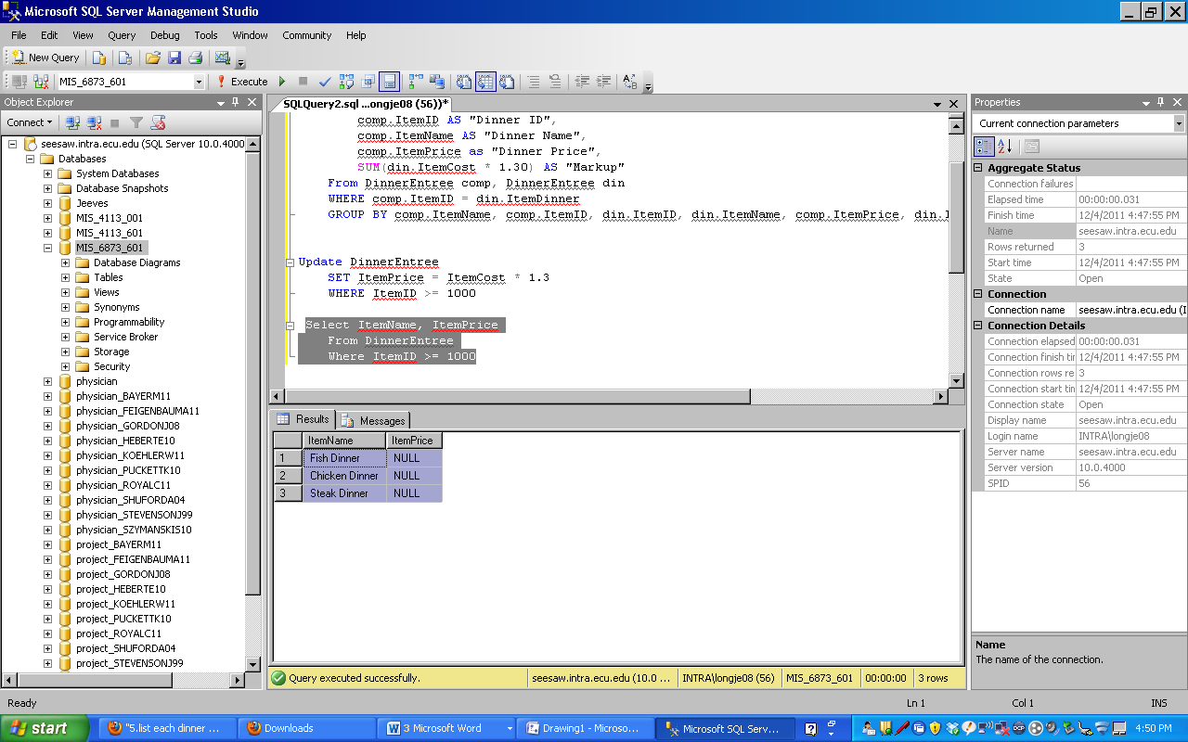

**Name the file Assignment4-*yourlastname*.doc Be sure to put your name in the Word file and insert the ERD and SQL statements under each question. Submit this document containing the ERD and all SQL code to the**

**Assignment 4 Submission link prior to the due date/time.**